**Bug 2 Output:**Checked out of room 101.   
After checkout was then able to add a restaurant service costing $20 to the room.  
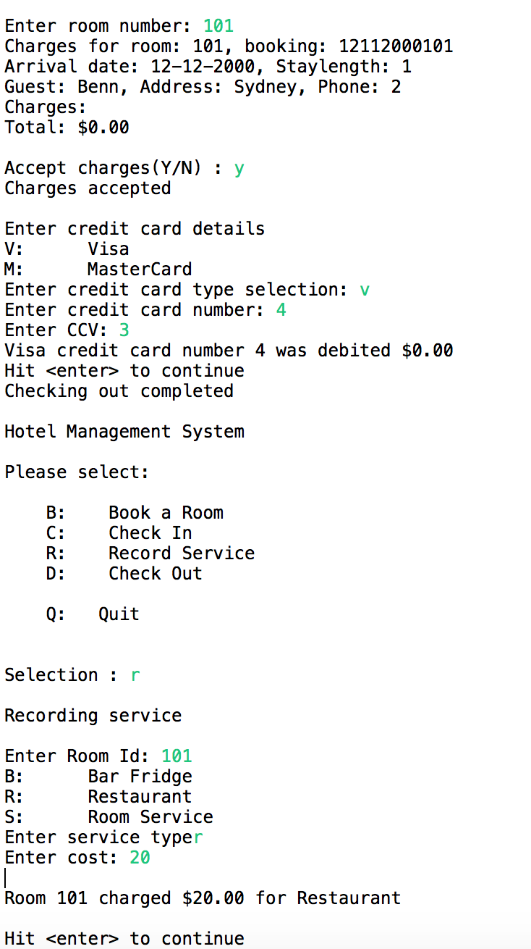

**Output after bug 2 fixed:**

Checked out of room 101.  
Selected Record Service from the menu but was unable to add anything, as there is now no active booking for that room.  
